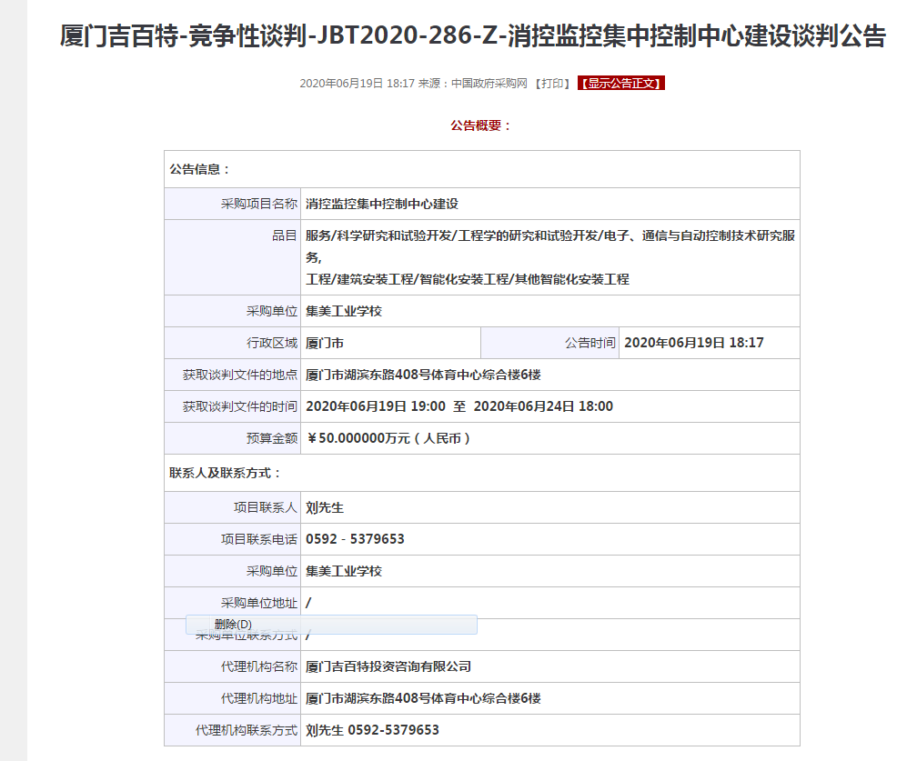

http://www.ccgp.gov.cn/cggg/dfgg/jzxtpgg/202006/t20200619_14511948.htm